PipeTobaccoCouncil.org
Breadcrumb Home page URL is incorrect.
1/12/24

- The Home page breadcrumb URL does not take you to the Home page. It takes you here to this link which is incorrect – http://box2269.temp.domains/~cigarass/pipetobaccocouncil-org/
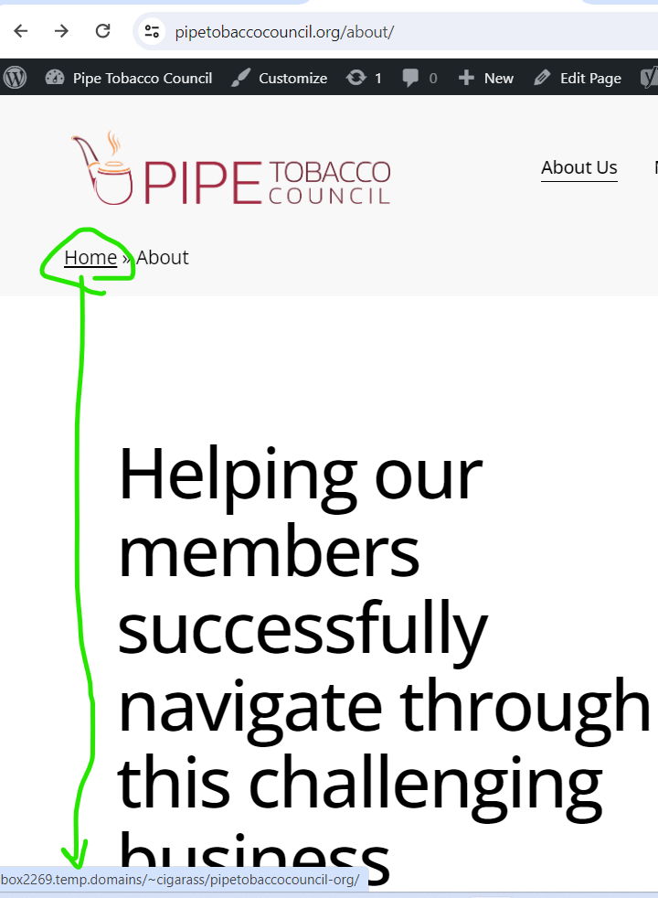

- The link takes you here

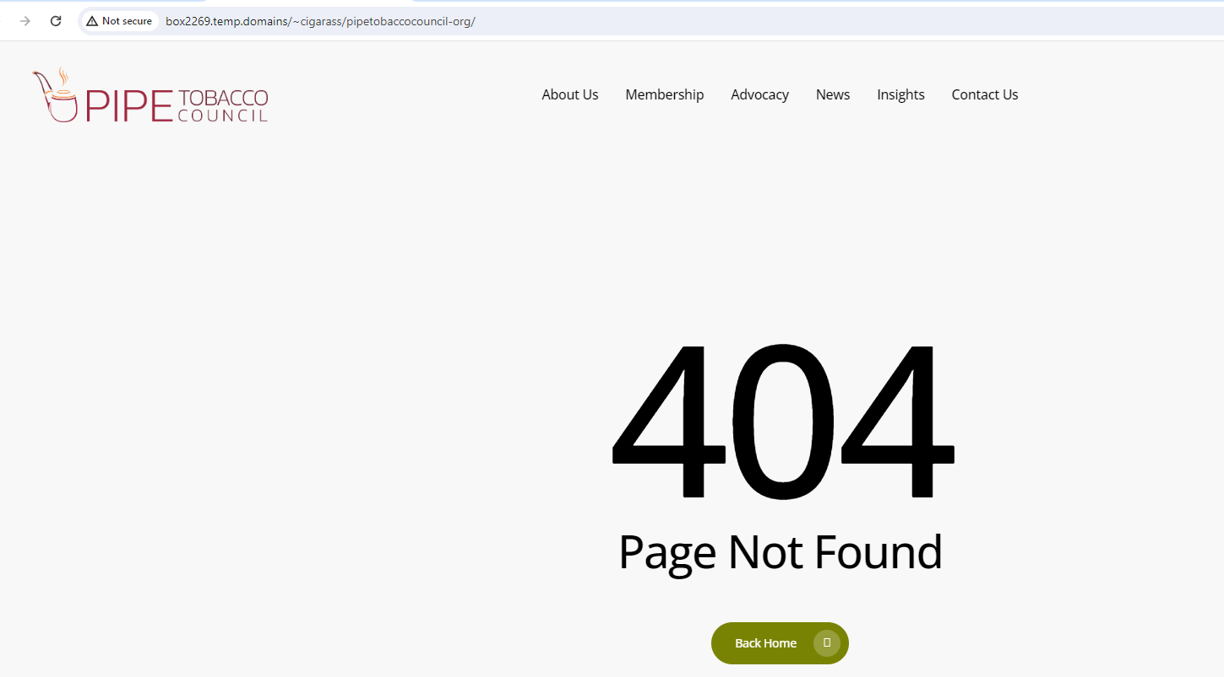

Here is the Yoast SEO plugin coding below:

BUT WHERE DO I GO TO CHANGE THE URL n the Yoast coding in the style sheet to the correct Home page link

<!-- This site is optimized with the Yoast SEO plugin v21.8 - https://yoast.com/wordpress/plugins/seo/ -->
<title>About - Pipe Tobacco Council</title>

<!-- Admin only notice: this page does not show a meta description because it does not have one, either write it for this page specifically or go into the [Yoast SEO - Settings] menu and set up a template. -->

<link rel="canonical" href="https://pipetobaccocouncil.org/about/" class="yoast-seo-meta-tag" />
<meta property="og:locale" content="en_US" class="yoast-seo-meta-tag" />
<meta property="og:type" content="article" class="yoast-seo-meta-tag" />
<meta property="og:title" content="About - Pipe Tobacco Council" class="yoast-seo-meta-tag" />
<meta property="og:url" content=https://pipetobaccocouncil.org/about/ class="yoast-seo-meta-tag" />
<meta property="og:site_name" content="Pipe Tobacco Council" class="yoast-seo-meta-tag" />
<meta property="article:modified_time" content="2024-01-04T20:10:33+00:00" class="yoast-seo-meta-tag" />
<meta name="twitter:card" content="summary_large_image" class="yoast-seo-meta-tag" />
<meta name="twitter:label1" content="Est. reading time" class="yoast-seo-meta-tag" />
<meta name="twitter:data1" content="10 minutes" class="yoast-seo-meta-tag" />
<script type="application/ld+json" class="yoast-schema-graph">{"@context":https://schema.org,"@graph":[{"@type":"WebPage","@id":https://pipetobaccocouncil.org/about/,"url":https://pipetobaccocouncil.org/about/,"name":"About - Pipe Tobacco Council","isPartOf":{"@id":http://box2269.temp.domains/~cigarass/pipetobaccocouncil-org/#website},"datePublished":"2023-04-06T01:26:01+00:00","dateModified":"2024-01-04T20:10:33+00:00","breadcrumb":{"@id":https://pipetobaccocouncil.org/about/#breadcrumb},"inLanguage":"en-US","potentialAction":[{"@type":"ReadAction","target":[https://pipetobaccocouncil.org/about/]}]},{"@type":"BreadcrumbList","@id":https://pipetobaccocouncil.org/about/#breadcrumb,"itemListElement":[{"@type":"ListItem","position":1,"name":"Home","item":http://box2269.temp.domains/~cigarass/pipetobaccocouncil-org/},{"@type":"ListItem","position":2,"name":"About"}]},{"@type":"WebSite","@id":http://box2269.temp.domains/~cigarass/pipetobaccocouncil-org/#website,"url":http://box2269.temp.domains/~cigarass/pipetobaccocouncil-org/,"name":"Pipe Tobacco Council","description":"","potentialAction":[{"@type":"SearchAction","target":{"@type":"EntryPoint","urlTemplate":http://box2269.temp.domains/~cigarass/pipetobaccocouncil-org/?s={search_term_string}},"query-input":"required name=search_term_string"}],"inLanguage":"en-US"}]}</script>
<!-- / Yoast SEO plugin. -->

